THE COMPTON EFFECT
Last Revised: January 5, 2007

QUESTION TO BE INVESTIGATED:
How does the energy of a scattered photon change after an interaction with an electron?

INTRODUCTION:
When a photon is scattered by an electron, the electron recoils, thereby taking away some of the energy. The scattered photon is then of less energy than the incident photon. Taking the energy of the photon to be E = hν (= hc/λ), and its momentum to be p = E/c (= h/λ = hk). Using only the laws of conservation of momentum and energy one can derive the Compton formula:

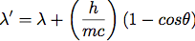 (1)
or
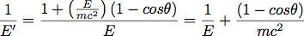 (2)

Where primes indicate quantities associated with the scattered photon, θ is the angle through which it scatters, m is the electron mass, h is Planck’s constant, c is the speed of light in vacuum, and λ is the wavelength of the photon. Note that these expressions are relativistic, implying that the electron recoils with considerable energy.

EXPERIMENT:

!! In this experiment a very intense 137Cs radioactive source is used to provide 661.6 keV photons. Extreme caution should be used to insure that you are not exposed to the direct radiation from this source for any extended period of time. Let the instructor remove the source from its container and insert it in its collimating shield, if needed. Using the Geiger counter, periodically monitor the radiation level in your vicinity to be sure it is at a safe level. !!

Before beginning this experiment it will be valuable to understand the operation of Eq. (1). Construct a table of angle versus theoretical photon energy for angles from 0 to 120° in steps of 10° so that you will have some idea of what you will be seeing during the experiment.

The scattered photons will be detected by a scintillation counter (composed of Nal(Tl)) which produces output pulses of a height which is directly proportional to the amount of energy that the photon loses in the sodium iodide crystal. These pulses are amplified, digitized and stored in the computer memory into which the input pulses are sorted according to their pulse height (α energy). You will use a Spectech UCS20 spectrometer to histogram your data.

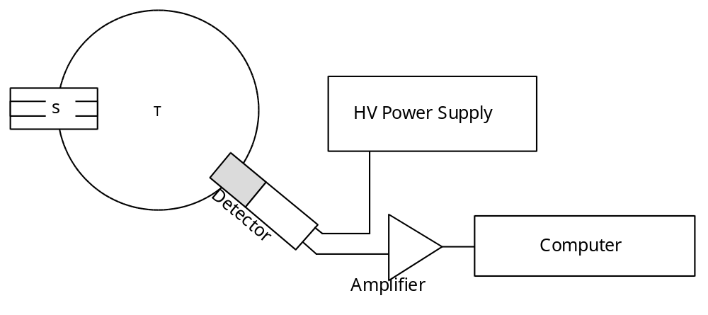
Set the high voltage (HV) power supply to be positive. Set the HV initially at +900 volts. Never exceed 1000 volts! The amplifier gain should be set to a value between 6 and 12. Allow the amplifier and detector to warm up at least 45 minutes before taking your final data.

Channel to Energy Calibration:
Data will be collected by the electronics in this experiment and presented to you in the form of a histogram. In order to make any sense of this histogram you must understand the relationship between channel (bin) number and the energy of the detected photon. To perform this calibration you will use a low intensity “button” source with known characteristics. Take a spectrum using a button source by hanging it directly in front of the plastic window on your detector.

You will want to adjust the signal amplifier to give a useful signal. Using the cursor on the computer screen, roughly determine (by eye) the channel number corresponding to the photopeak in this spectrum. Change the gain of the amplifier until the photopeak occurs roughly in channel 300 to 400. Record the channel number and peak energy in your logbook. Take additional data using a 22Na, 54Mn, 60Co, and a 133Ba source. Plot the observed channel numbers versus the corresponding energies to obtain the (nearly linear) relation between channel number and energy. You will need to consult Table A, which is presented later. Initial peak channel numbers should be plotted as you take data. Use the rather clean peaks for cesium and sodium to figure out the highest energy barium lines and then work your way down to the lower energy peaks of barium. This will provide a rough calibration all across the region where the Compton photons will be found. (Except for 22Na, the aforementioned sources are all gamma emitters. 22Na emits e+. The e+ stops and annihilates an e- to produce two 511 keV photons.)

There are beta (electron) peaks that can confuse you. By initially placing a thin piece of lead between the source and the detector, these peaks will disappear. Use this method to identify uninteresting peaks. Don't take your final data with the lead sheet in place!

Now take a spectrum of radiation from the strong Cs source with the aluminum scattering rod in place and the detector at an angle of 30°. Take a second data set without the scattering rod. Subtract these two data sets in Excel to get an idea of the location of the signal peak. This effectively removes the background from under the signal. Note the approximate energy and the total number of counts in the peak. Save the data. Repeat this procedure at angles of 60°, 90°, and 120°. Using your rough calibration curve (from above), plot the energy of the peak versus angle, and fit a smooth curve. Compare this with the table you prepared of theoretical energy vs. angle.

Use the data from above to estimate the time that you will need to run to get at least 10,000 counts under the peak. Prepare a table for the next lab period showing the estimated times versus angle in angle increments of ten degrees from 0 to 120 degrees.
Collect Data:
Turn on the full system, HV, Amplifier, at least one half hour before taking any serious data.

Repeat the calibrations for all of the sources and record each spectrum on disk. This part must be done during the same period that the Compton energies data is taken.

For each scattering angle you will take two sets of data, one with the aluminum scattering rod present, and one without. Data taken without the aluminum rod will be your background. In order to supplant drift of data, you should take half of your “rod present” data before your background and half after. Do this for scattering angles from 0 to 120 degrees in steps of 10 degrees. Look for the signal peak in your “rod present” runs using your table of prepared energies vs. angle. Record this rough position in your logbook and plot it on your energy vs. angle plot.

Take a final re-calibration run using 137Cs to verify that your calibration curve has not shifted. Record the spectrum on disk.

Note: Care must be taken to use maximum collimation of the source and maximum shielding of the detector if the peaks are to be clean. Try to understand the source of any other peaks in the two spectra (rod present and out).

Analysis of Calibration Data:
Fit each calibration peak to a Gaussian. The background on these signals should fit to a quadratic. You will want to know the error on the bin number. This can be achieved by assuming a chi-squared of 1 for these fits.

Fit a straight line and a quadratic polynomial to your Energy (y axis) versus peak channel number plot. Choose the fit which gives the best reduced chi-squared. Discuss the fits. You will need to use the full error matrix to do the final analysis, so save this information.

Analysis of Compton Data:
These data fall into two categories, signal (S) and background (B). The “rod present” data (Y₁) contain both signal and background events, while your “target out” run (Y₂) contains only background (B’) events. One can subtract the background events from the signal events channel by channel and fit the result.

Where N is the correction factor taken into account for the different times of data acquisition. Note that the background for the two runs are not necessarily identical, since they are taken independently. The error in the yields Y1 and Y2 is just (see Lyons p. 56)

.
One can propagate these errors to get the error in the signal

.

Fit all of the background-subtracted signal-peaks using a non-linear fitter and minimizing the reduced chi-squared. Use the error for each channel as defined above in your calculation of reduced chi-squared. Determine the uncertainties in the peak position as was done in the calibration analysis.

To convert your Compton peak channel numbers into energy, use the calibration fit function you derived.

The fit will give you an error in the energy that will be the error due to the uncertainty in the calibration.

To get the energy error associated with the uncertainty in the Compton peak one can simply multiply the slope times the uncertainty in peak position, where the slope comes from the fit.

You now have 2 errors for each peak. These must be combined to yield a total error for the peak position. This may be done by adding the errors in quadrature:

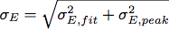

Plot the theoretical and experimental Compton energy vs. angle. Discuss the departure of any of the points from the theoretical curve.

Compare your results with the predictions of Compton's formula and use this to extract the electron mass and incident photon energy. This may be conveniently done by plotting 1/E' versus (1 - cos θ), which should give a straight line.

- Find the fitted slope of this line and use your result to calculate mc2 and its error. Compare your answer with the accepted value of 511 keV.
- Find the fitted intercept and its error. Use this to calculate the energy (and error) of the incident photon. Compare this with the accepted value.
- Estimate the probability that each of the above results are in agreement with the accepted values.
- Calculate the energies at each angle you measure assuming first that the system is non-relativistic and then assuming that it is relativistic. Which calculation matches you data best?

Additionally, derive an expression for the shifted energy using the classical expression for the electron's energy (E = p2/2m). Prepare a graph of E' versus θ using this expression. Plot Eq. 2 and your data on the same graph. Are you able to experimentally distinguish between the two curves? Do your results rule out the use of classical kinematics for explaining the Compton effect?

There are some interesting effects that are seen at small angles (0 through about 20 degrees) if one blindly subtracts the background from the signal. Examine your data (signal and background separately) and explain these effects in terms of what, where and how much is being scattered into and out of the detector. Is the “normal” background subtracted data in this region adequate to use in the comparison with Compton’s theory? Can you propose a simple method for extracting correct signal in spite of these effects?

REFERENCES:

1. Melissinos & Napolitano. Experiments in Modern Physics. 2nd Ed.
Academic Press, 2003. Pp. 313-314, 369-385.
2. A. H. Compton, Phys. Rev. 21, (1923) 483; Phys. Rev. 22, (1923) 409

APPENDIX:
Isotope | Gamma Ray Energies in MeV, (Intensity)
¹³⁷Cs | 0.662 (85%)
²²Na | 0.511 (180%)  1.275 (100%)
¹³³Ba | 0.080 (36%)  0.276 (7%)  0.302 (14%)  0.356 (69%)  0.382 (8%)
⁵⁶Mn | 0.835 (100%)
⁶⁵Zn | 0.511 (3.4%)  1.115 (49%)

Table A. Available sources and their energies.

